**PHARMALOGY**

**BY**

**ANMONA MAMUN MONISHA**

**ID: 161-15-6914**

**AND**

**MD. AYUB SHAMIM**

**ID: 161-15-6717**

This Report Presented in Partial Fulfillment of the Requirements for the Degree of Bachelor of Science in Computer Science and Engineering.

Supervised By

**Rubaiya Hafiz**

Lecturer

Department of CSE

Daffodil International University

Co-Supervised By

Lecturer

Department of CSE

Daffodil International University



**DAFFODIL INTERNATIONAL UNIVERSITY**

**DHAKA, BANGLADESH**

**FEBRUARY 2019**

**APPROVAL**

This Project titled **“PHARMALOGY”**, submitted by ANMONA MAMUN MONISHA, and MD. AYUB SHAMIM to the Department of Computer Science and Engineering, Daffodil International University, has been accepted as satisfactory for the partial fulfillment of the requirements for the degree of B.Sc. in Computer Science and Engineering and approved as to its style and contents. The presentation has been held on 20/11/18.

**BOARD OF EXAMINERS**



**Dr. Syed Akhter Hossain**

**Professor and Head** **Chairman**

Department of CSE

Faculty of Science & Information Technology

Daffodil International University



**Dr. Sheak Rashed Haider Noori** **Internal Examiner**

**Associate Professor and Associate Head**

Department of CSE

Faculty of Science & Information Technology

Daffodil International University



**Md. Zahid Hasan** **Internal Examiner**

**Assistant Professor**

Department of CSE

Faculty of Science & Information Technology

Daffodil International University



**Dr. Mohammad Shorif Uddin** **External Examiner**

**Professor**

Department of Computer Science and Engineering

Jahangirnagar University

**DECLARATION**

We hereby declare that; this project has been done by us under the supervision of **Rubaiya Hafiz, Lecturer, Department of CSE** Daffodil International University. We also declare that neither this project nor any part of this project has been submitted elsewhere for award of any degree or diploma.

**Supervised by:**



**Rubaiya Hafiz**

Lecturer

Department of CSE

Daffodil International University

**Co-Supervised by:**



Lecturer

Department of CSE

Daffodil International University

**Submitted by:**



**ANMONA MAMUN MONISHA**

ID: 161-15-6914

Department of CSE

Daffodil International University



**MD. AYUB SHAMIM**

ID: 161-15-6717

Department of CSE

Daffodil International University

**ACKNOWLEDGEMENT**

First, we express our heartiest thanks and gratefulness to almighty ALLAH for his divine blessing makes us possible to complete our final year project successful. But there are others, without their support, encouragement and appreciation we would not be able to bring our project into light of success. We, from the core of our heart, want to thank them all.

We want to thank our honorable **Supervisor Rubaiya Hafiz, Lecturer,** Department of Computer Science & Engineering, Daffodil International University. Deep knowledge and keen interest of our supervisor in the field of “Database management system” to carry out this project. Her endless patience, encouragement, expert advice and above all her friendly behavior towards us have made it possible to complete this project.

We would like to express our heartiest gratitude to **Dr. Syed Akhter Hossain, Professor and Head**, Department of CSE, for his kind help to finish our project and also to other faculty member and the staff of CSE department of Daffodil International University.

Next, we must thank and acknowledge our university, Daffodil International University. We also want to thank our beloved classmates and other students of the university who took part in research purpose for our project and appreciated our work.

Lastly, we want to thank our beloved families, who were always by our side and kept faith on us. Without our family support, we could never be here, we cordially thank them for this. We also thank our friends for their support and help to us.

**ABSTRACT**

In this project, we have built up web based with different types of necessary features and unique features. The main purpose of ‘PHARMALOGY’ is to find out your desired medicines with the information of your nearby pharmacies. This website has information about the doctors of Bangladesh, the medicine companies of Bangladesh, and a rare zone as well as a restricted zone depending on the location of medicine and the category of medicines. There are a blog where you can know about the medicines you are using or prescribed for you by your doctor. There are also some health tips and home remedies techniques. We have used JAVASCRIPT, HTML, CSS for design this website. After finishing our website we also implemented an android application for more user friendly. In the wake of finishing all task, the website and application tested in various stages and was discovered working effectively. Now users no need to go here and there for finding medicines, they simply find the place where their desired medicine are by using our website as well as application.

|  |  |  |
| --- | --- | --- |
| **FIGURES** | **LIST OF FIGURES** | **PAGE NO** |
| 01 | Screenshot of related work | 10 |
| 02 | Business process model | 12 |
| 03 | Requirement collection and analysis | 14 |
| 04 | Use case modeling | 15 |
| 05 | Logical data model | 16 |

|  |  |  |
| --- | --- | --- |
|  | **TABLE OF CONTENT** |  |
| **CONTENT** | | **PAGE** |
| Board of Examiners | | I |
| Declaration | | Ii |
| Acknowledgements | | Iii |
| Abstract  List of Figures | | Iv  V |
| **CHAPTER 1: INTRODUCTION** | | 8-10 |
| 1.1 | Introduction | 8 |
| 1.2 | Motivation | 8 |
| 1.3 | Objectives | 8 |
| 1.4 | Expected Outcome | 9 |
| 1.5 | Report Layout | 9 |
| **CHAPTER 2: BACKGROUND** | | 10-11 |
| 2.1 | Introduction | 10 |
| 2.2 | Related Works | 10 |
| 2.3 | Comparative Studies | 11 |
| 2.4 | Challenges | 11 |
| **CHAPTER 3: REQUIREMENT SPECIFICATION** | | 12-17 |
| 3.1 | Business Process Modeling | 12 |
| 3.2 | Requirement Collection and Analysis | 14 |
| 3.3 | Use Case Modeling and Description | 15 |
| 3.4 | Logical Data Model | 16 |
| **CHAPTER 4: DESIGN SPECIFICATION** | | **17-22** |
| 4.1 | Home page Introduction design | 17 |
| 4.2  4.2.1  4.2.2  4.2.3 | Implementation Requirements  Resource Requirement  Xampp  Visual Studio Code | 21  21  21  21 |
| **CHAPTER 5: IMPLEMENTING AND TESTING** | | 22-26 |
| 5.1 | Implementation of Database | 22 |
| 5.2 | Implementation of Front-end Design | 23 |
| 5.3 | Implementation of Interactions | 25 |
| 5.4 | Testing Implementation | 26 |
| **CHAPTER 6: CONCLUSION AND FUTURE SCOPE** | | 27 |
| 6.1  6.2 | Discussion and Conclusion  Goal | 27  27 |
| 6.3 | Scope for Further Developments | 27 |
| **REFERENCES** | | 28 |
| **APENDIX** | | 29 |
| Appendix A: Project Reflection | | 29 |
| Appendix B: Related Diagrams | | 29 |

**CHAPTER 1**

**Introduction**

* 1. **Introduction**

This project is basically a website for the pharmacies in Bangladesh. We are trying to make a platform so that user can easily find out the medicines which they need.

This website will help the customer for searching their desire medicines and as a result they will find the pharmacies where that medicines are. PharmaLogy will also help the customers to let them know about the information of the hospitals and pharmaceutical companies in Bangladesh.

There are an emergency service which will help to find the information about nurses in emergency cases. We included a blog about medicines, health suggestions. User can know about the normal test report values in report section as well as can get the cabin and test costs in various hospitals in Bangladesh.

After making the website we will make an android application related to our site so that it can be more user friendly.

There are no such website or applications till now in Bangladesh. Only a few websites exist and these are E-commerce and an application is exist where only a few pharmacies information has.

* 1. **Motivation**

For Customers/users-

It will reduce the sufferings of people. By using our site one can easily know where the pharmacies and availability of medicines is.

* 1. **Objective**

Using this system user will be able to know about their medicines.

**Services at a glance:**

* Firstly searching the medicine by the medicine name or generic name.
* Searching your nearby pharmacies by selecting division, district and thana.
* User can get some health suggestions.
* There are the information about the hospitals and the doctors of Bangladesh and also the information about the pharmaceutical companies in Bangladesh.
* Some home remedies techniques for first aid.
* Information about cabin and test costs in various hospitals.
* Idle test reports information.
* Get nursing services at emergency cases.
* If you need any medicine in emergency at late night then you can find out which pharmacy in open nearby you and which are closed.
* There are a blog also which will let you know about everything of your medicines.
* We also include an alert system for those who are searching for a medicine but couldn’t find right now. In that case if any pharmacy include that medicine to their shop then the customer get a notification via their given email. For getting this service the user must be get registered to our site.
  1. **Expected Outcome**
* At first customers need to register at our site as a consumer user.
* Alert system
* Finding nearby pharmacies.
* Finding nurses.
* Getting information.
* Health suggestions and home remedies.
* Blog about medicines.
  1. **Report Layout**

**In the chapter (1)** we have described about the introduction of the project, motivation, objective and expected outcome of our project.

**In the chapter (2)** we have described about the background of our work. We included the previous work which is related to our work. Also described about the comparative studies and find out the problems, challenges.

**In the chapter (3)** we have described about the requirements and some models like business process modeling, use case modeling, and logical data model. Also described about the designs, required data and analysis them.

**In the chapter (4)** we have described about the resources which are needed to build our site.

**In the chapter (5)** we have described about the implementation and testing part. It includes the standards of coding, test results, reports etc.

**In the chapter (6)** we conclude our site and discuss about the future scope for further development.

**CHAPTER 2**

**Background**

**2.1 Introduction**

Bangladesh is a developing country. Bangladesh is developing in its every section. Nowadays everything is becoming internet based.

**2.2 Related Works**

There are no such works yet. We found an application in play station which has only some information about pharmacies, and that app is not efficient enough. There are 10 to 12 e-commerce websites. 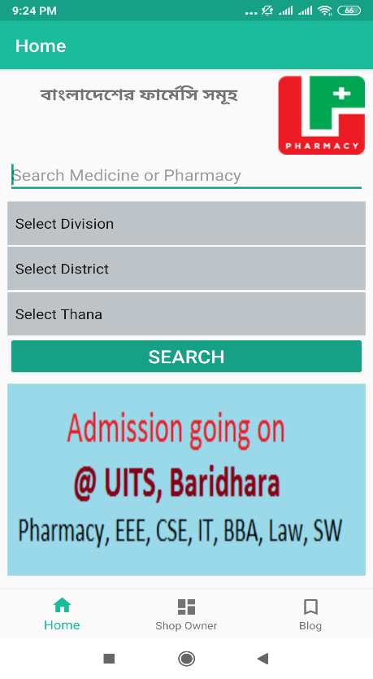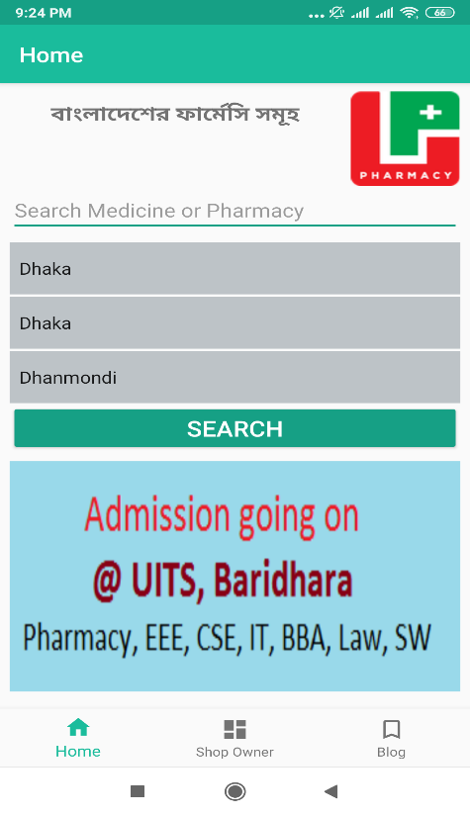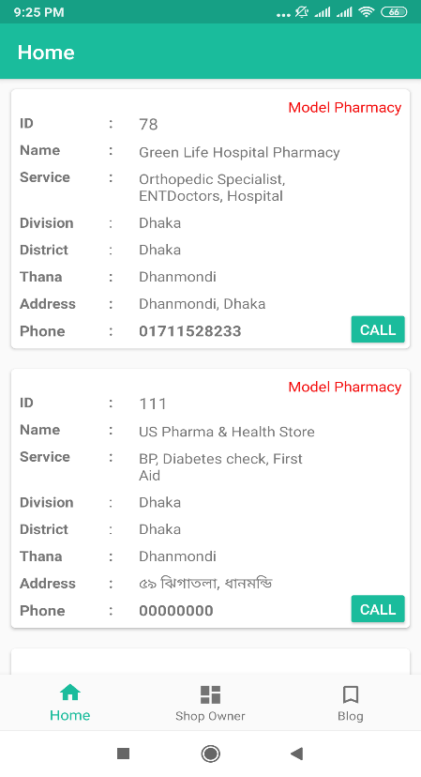

These are the existing app’s screenshot.

**2.3 Comparative studies**

Comparing previous works our project is unique. There are features like finding nurses in emergency cases, searching medicines at home, knowing about medicines, doctors, hospitals etc, home remedies, health tips, idle rest results and so on. There are no such websites or applications which can provide all these information in one place.

**2.4 Challenges**

To do our project we faced some problems-

* In bringing the pharmacy information in our project, some pharmacy owner was scared to giving us there information.
* We faced difficulties when we were finding the information about the nurses for our emergency service feature. We went to different hospitals for collecting their information. Some were really very co-operative and some had privacy concern.
* One big challenge was to generating our database. There are so much data about medicines. So, it was hard to organize that dataset.

At the end we overcame all the challenges by the grace of Almighty Allah.

**CHAPTER 3**

**Requirement Specification**

**3.1 Business Process Modeling**



**No No**

**Yes**

















**No**





**Yes**













**3.2 Requirement Collection and Analysis**













**Process**

**Entry**









**3.3 Use Case Modeling and Description**













**Moderator**





***manage***











**User**



**3.4 Logical Data Model**





















**CHAPTER 4**

**Design Specification**

**4.1 Home Page Introduction design**

We design our homepage with HTML, CSS and Javascript. Homepage is the summarization of a website. Here we introduce our whole feature in short with our logo and a navbar. The screenshots of the homepage are given below-

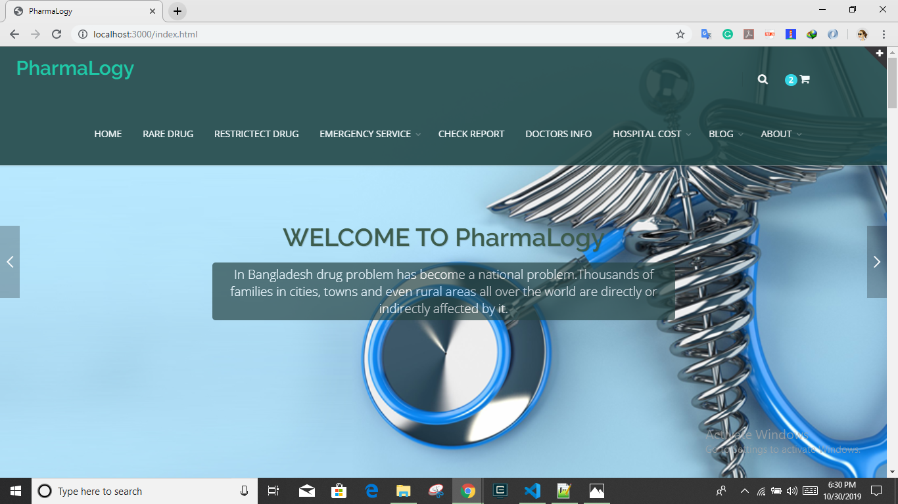

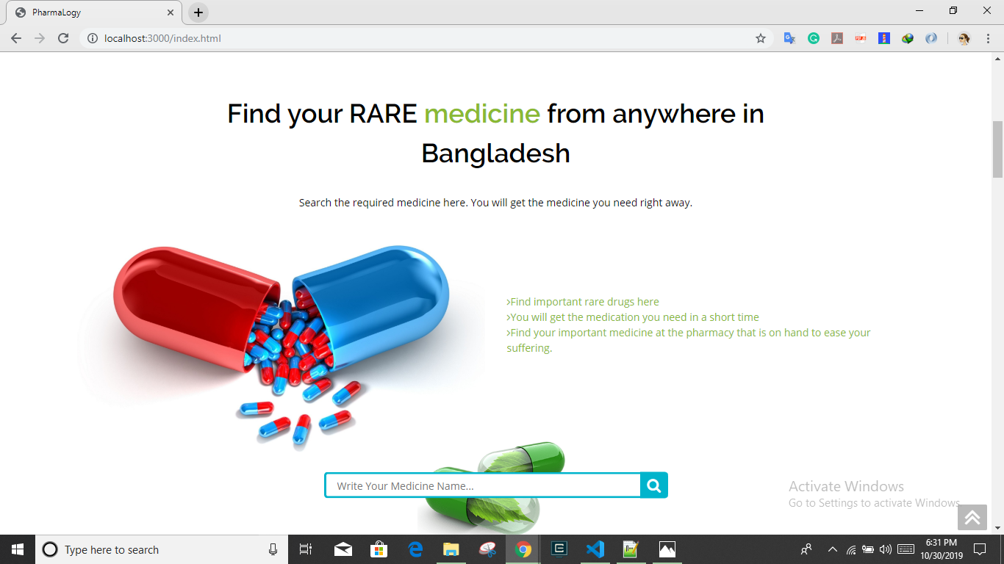

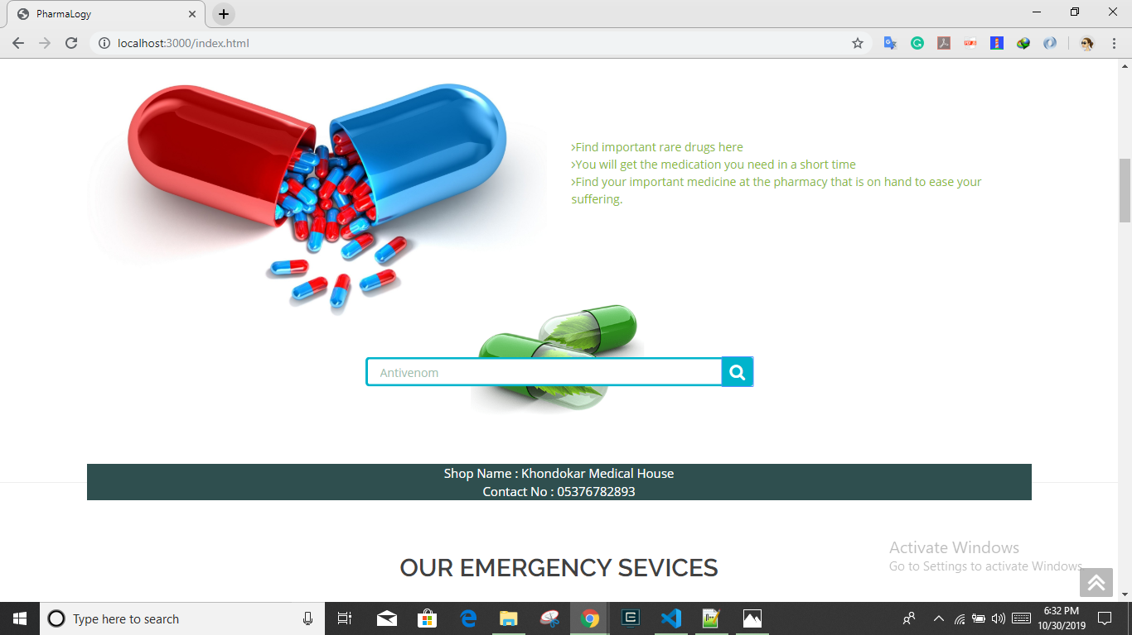

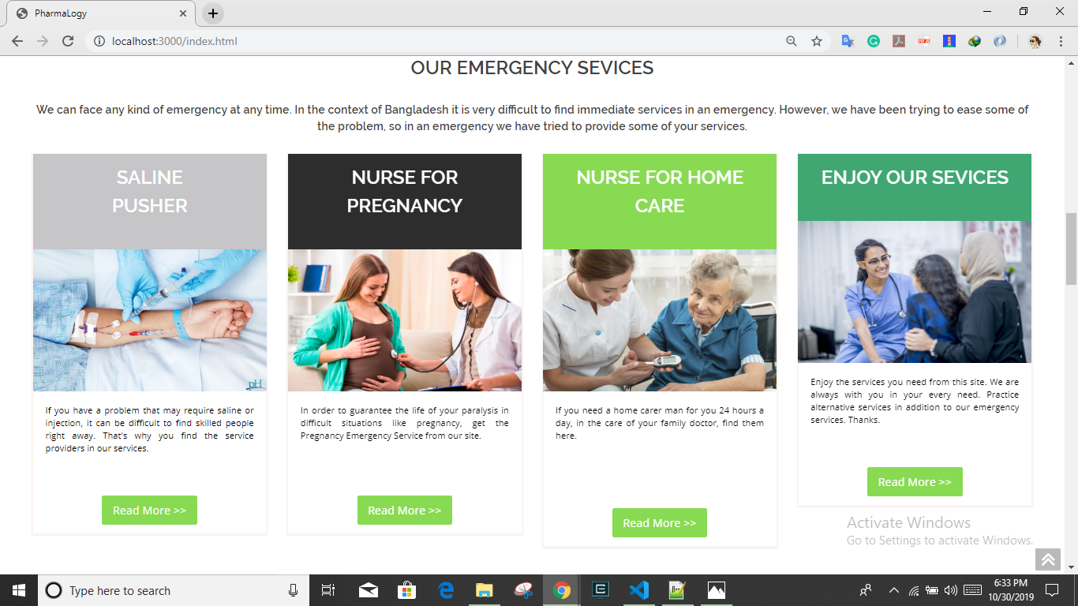

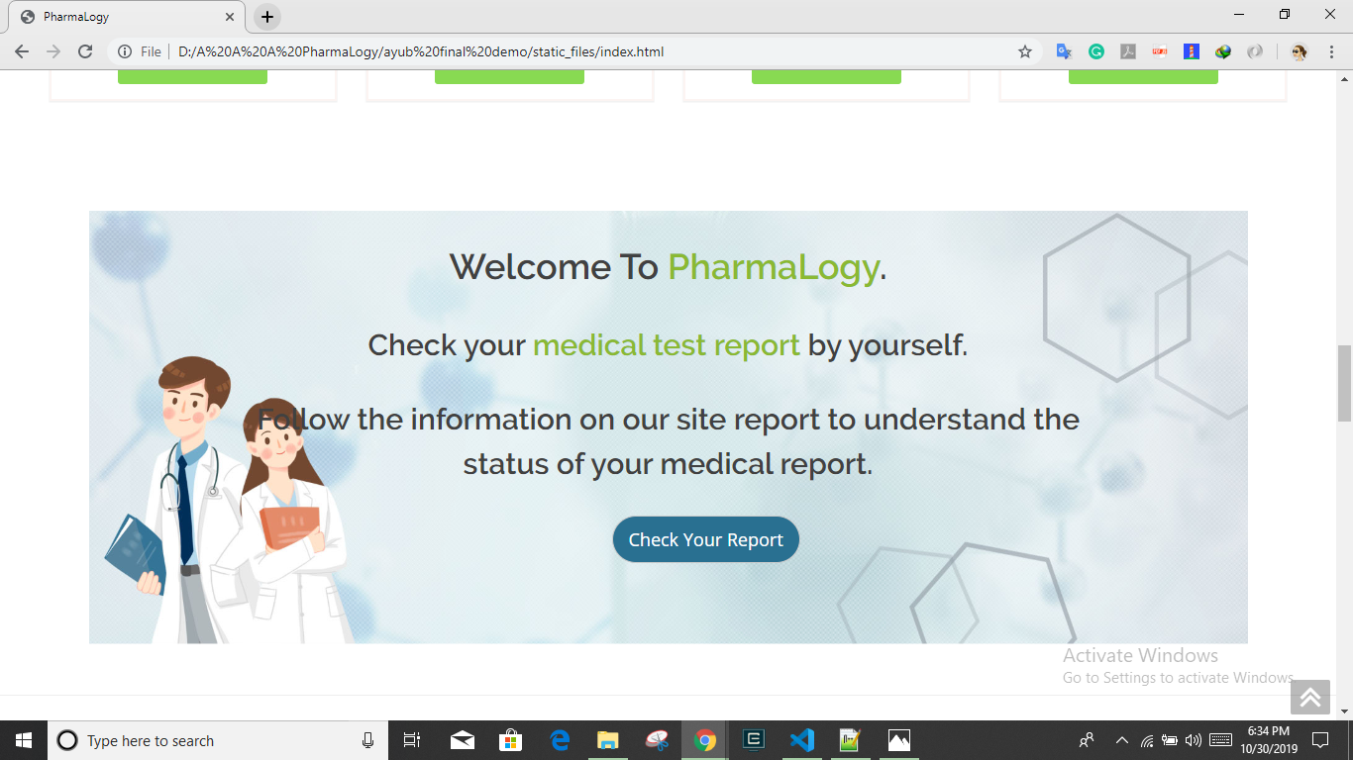

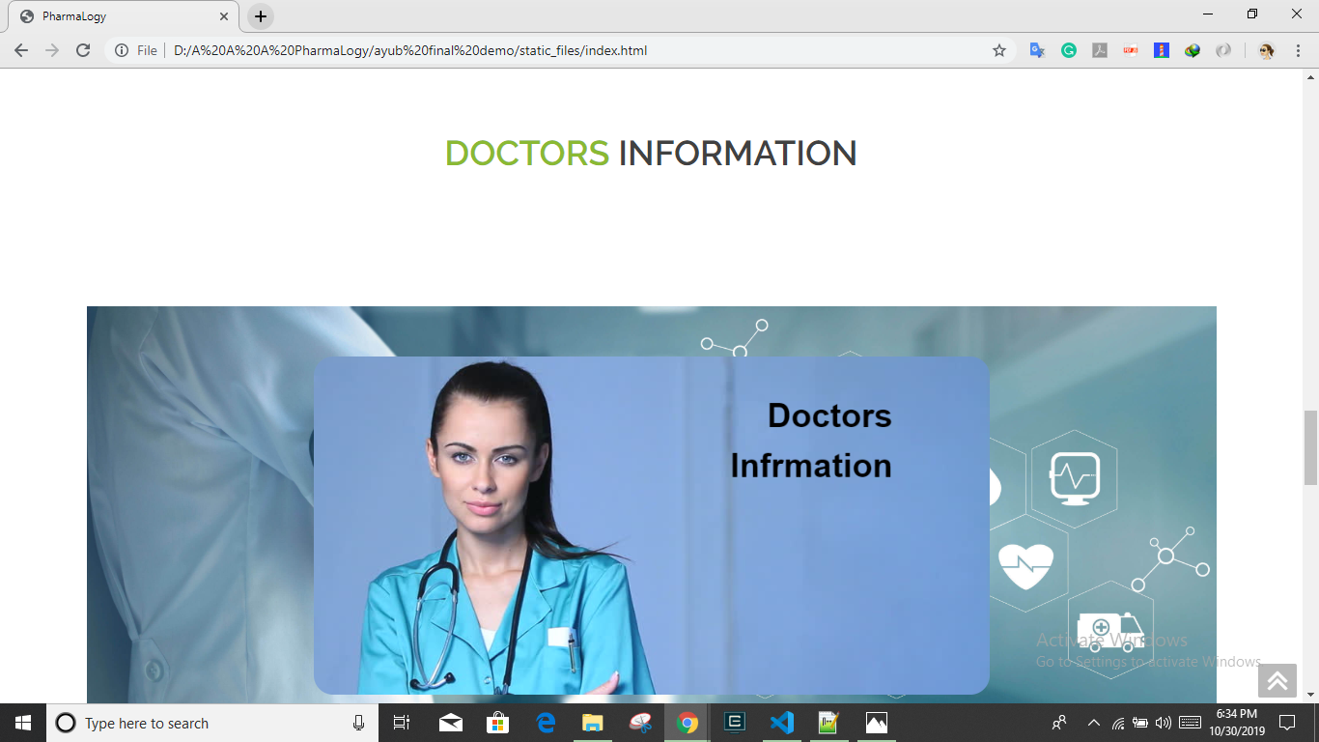

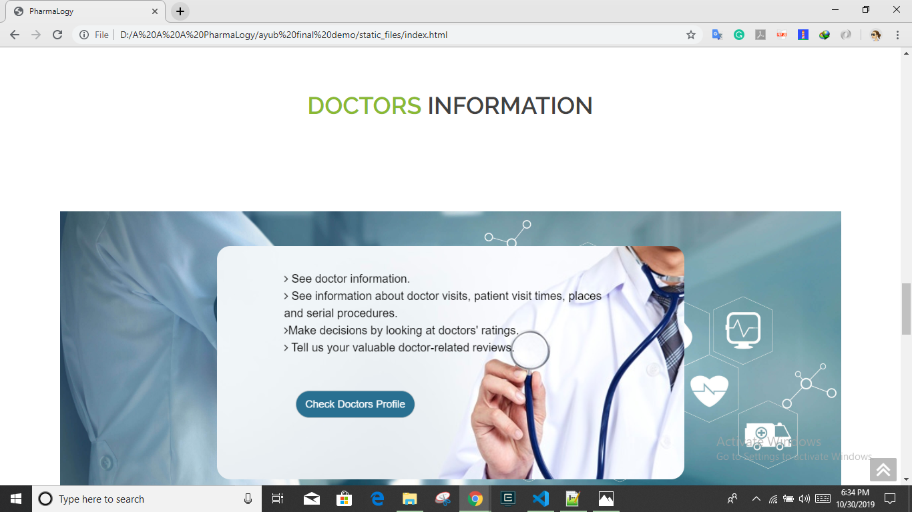

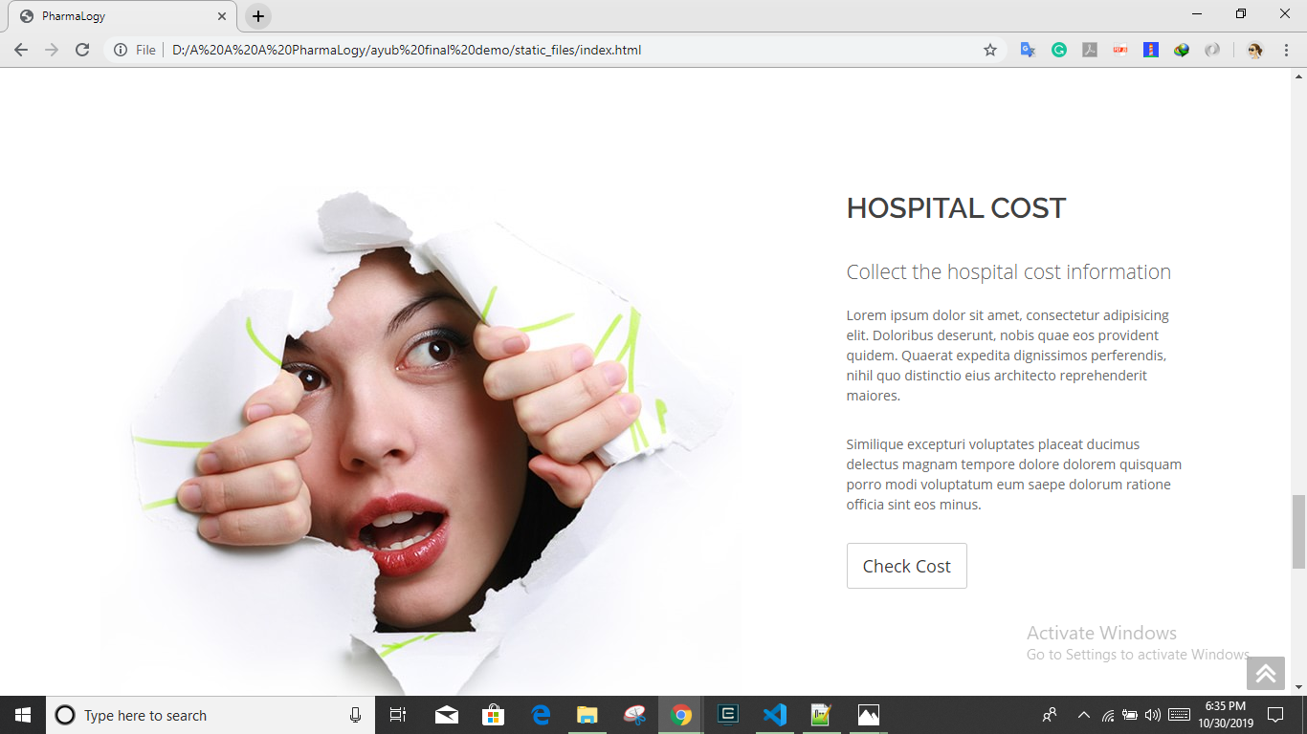

**4.2 Implementation Requirement**

We implemented our project with HTML, CSS, Bootstrap 4, JavaScript for front-end and as well as back-end. We also used express node.js and AJAX.

**4.2.1 Resource requirements**

For back-end, we read the documentation of node.js, google, and took help from some YouTube channels (for example: Twinkle Cats) to improve our knowledge.

For front-end, W3School was the best way to take help.

To enrich our website we analysis some hospital’s website like Ibn-Sina, Square etc.

**4.2.2 Xampp**

XAMPP is a free and open-source cross-platform web server solution stack package developed by Apache Friends, consisting mainly of the Apache HTTP Server, MariaDB database, and interpreters for scripts written in the PHP and Perl programming languages.

**4.2.3 Visual Studio Code**

Visual Studio Code is an IDE developed by Microsoft for Windows, Linux and macOS. This is our platform for developing our project. We generated our front-end code in VSCode. And use google chrome browser to run our website.

Express-Node.js: Express.js or simply Express is a web application framework for Node.js. We use express to a database like MySQL (for modeling) to provide a backend for our Node.js application. Express.js basically helps to manage everything, from routes to handling requests and views. Radis is a key/value store- commonly used for sessions and caching in Node.js applications.

AJAX: It stands for asynchronous JavaScript and XML. We used AJAX when we hit submit, JavaScript will make a request to the server, interpret the results, and update the current screen. In the purest sense, the user would never know that anything was even transmitted to the server.

**CHAPTER 5**

**Implementing and Testing**

**5.1 Implementation of Database**

Our database is about the medicine lists of Bangladesh according to pharmacy. At first we consider Dhanmondi area’s pharmacies to organize our database. As there are huge numbers of pharmacy in Bangladesh and as our project is a developing project so we will try to include more areas to enrich our project. There are some screenshots of database-

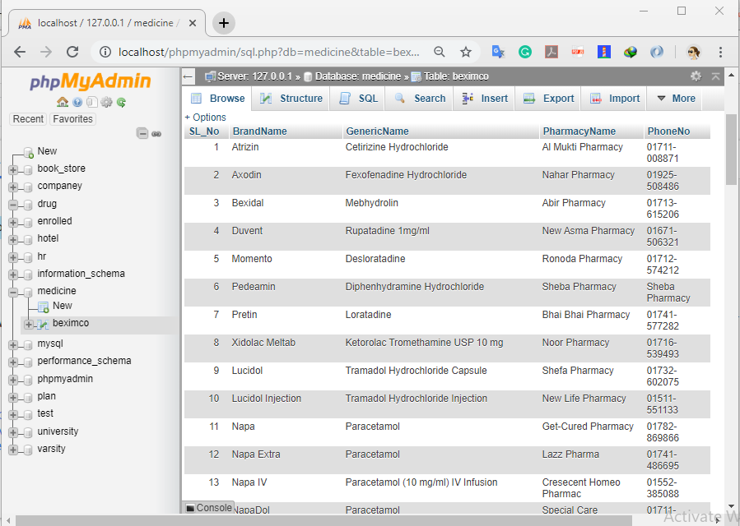

**5.2 Implementation of Front-end Design**

As we said earlier, we used basic HTML, CSS, bootstrap 4 and JavaScript to develop our projects front-end and also will be use Library React.JS because we will make the project single page application. We tried to enrich our website’s looks. We combined all of these so that the looks and the efficiency of our site could be more user friendly. Some screenshots are given below-

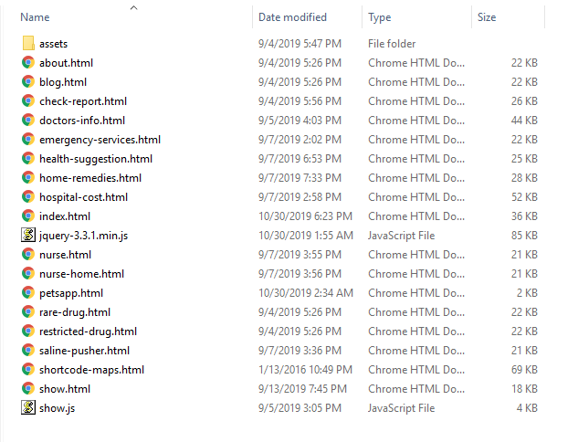

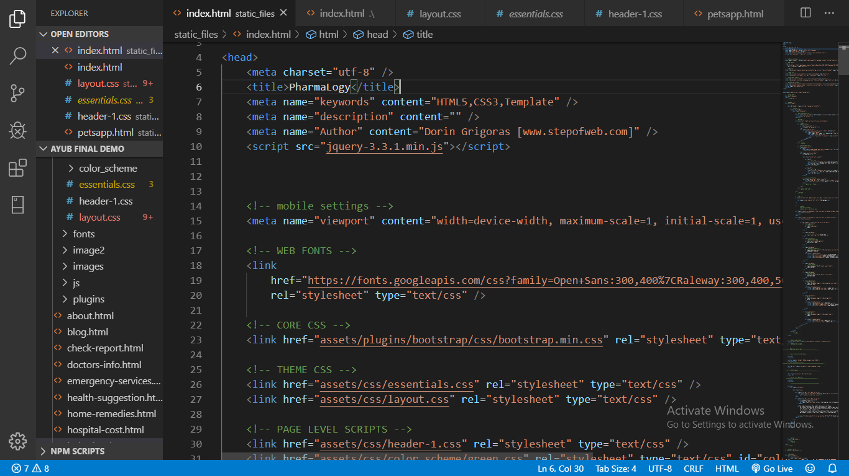

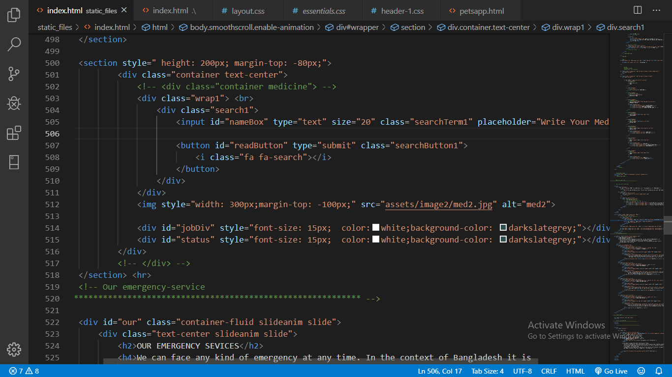

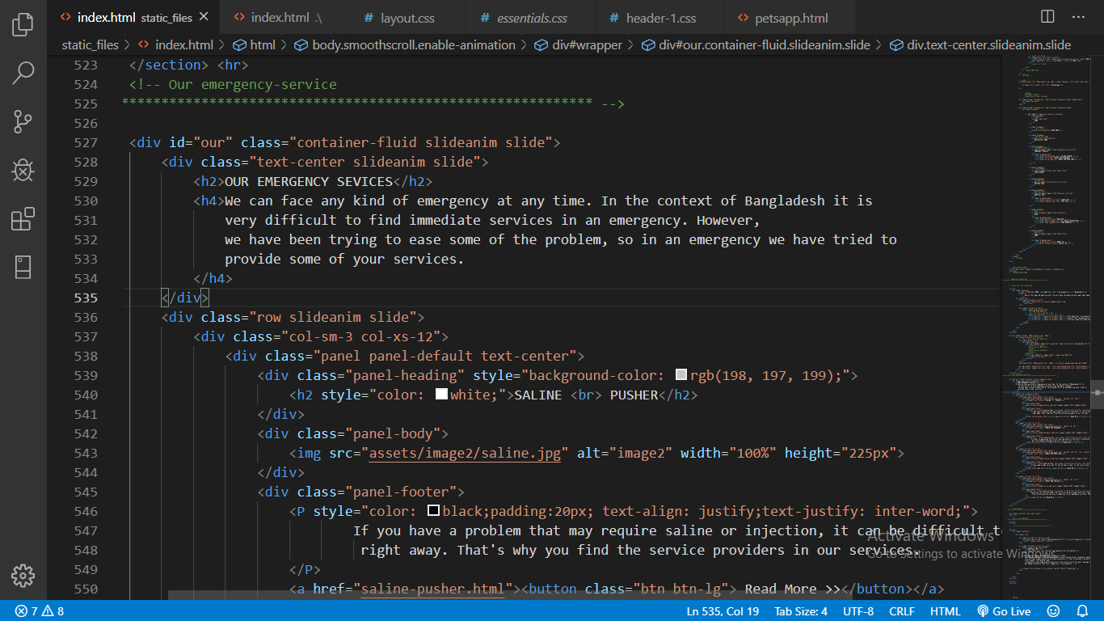

**5.3 Implementation of Interactions**

Connecting with database-

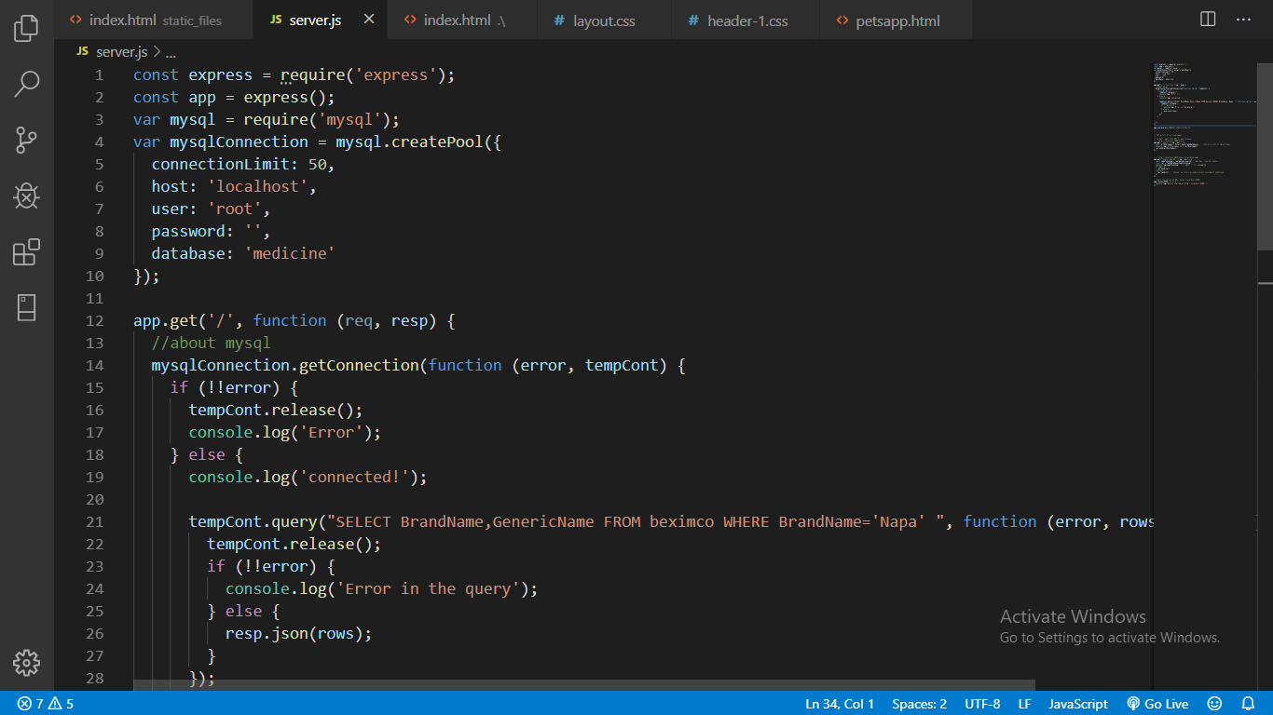

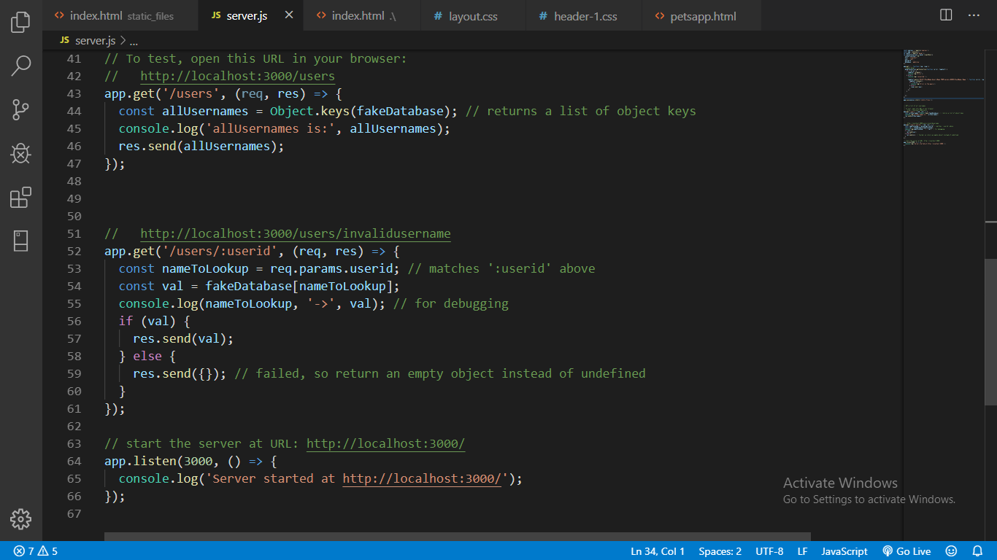

**5.4 Test Results and Report**

We tested our implemented code in Google chrome browser-

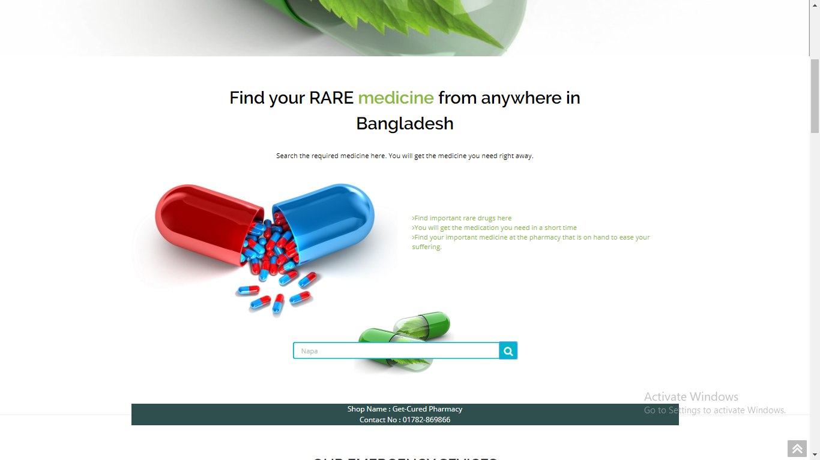

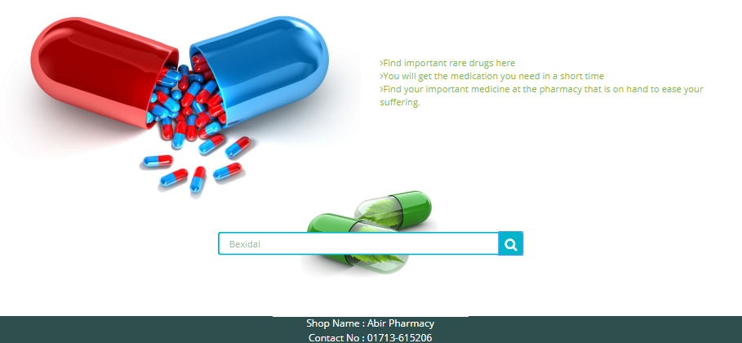

**CHAPTER 6**

**Conclusion and Future Scope**

**6.1 Discussion and Conclusion**

We combines pharmacy with technology that’s why we named our site as PharmaLogy. In Bangladesh there are many medicine websites which are basically e-commerce sites. We developed an informative website where user come to know where they can get their desire medicines. In finding medicines it is much hard to find sometimes, for these people need to go here and there to finding them but by our site people can easily find the location of their desire medicine. Also there are blogs about medicines, user can find home remedies techniques, get to know the information about the pharmaceutical companies of our country. People can also know about the costs of each hospitals. Most important thing is we are trying to give an emergency service where user can get nursing information like if someone need a saline pusher or a nurse for day care then it was hard to find them but by our site it is now more easier to find them.

**6.2 Goal**

Our goal is to make a complete platform for our medicine industry. Because in Bangladesh, most of the sectors are now much developed than this. There are no such informative website which can give us services and as well as information also. By our project users can get any of the medicine related information in one place. Basically we are trying to make life easier with this section also.

**6.3 Scope for Further Developments**

For further development we will try to bring all the district information in our site. We will try to add delivery services for inside and outside Dhaka so that people can get those medicines which are not available in everywhere. We will bring an application so that it will be more user friendly and available for everyone.

**REFERENCES**

1. W3School.com
2. youtube.com/twinklecats
3. google.com
4. https://www.pharmacy.com.bd/
5. https://www.epharma.com.bd/
6. http://bddrugs.com/pharmacy.php
7. https://www.lazzpharma.com/
8. https://www.squarehospital.com/
9. http://labaidgroup.com/specialized
10. https://www.ibnsinatrust.com/
11. https://nodejs.org/en/

**APENDIX**

**Appendix A: Project Reflection**

If we can complete our project with all over our country then it will be a huge platform for our pharmacy industry. It can be a startup business also. Our target is to work on it in future. Hope that it will help people a lot.

**Appendix B: Related Diagrams**

As there are no such work on our project but there is an app which is partially related to our work but no site is built yet. Only some e-commerce website is available on medicine.